ASSIGNMENT NO.: 2
PRN: 260740150018
NAME: PRATIK SUNIL ABHANG
Q1. Question: Explain OpenStack components with communication flow diagram
Answer / Solution
OpenStack is an open-source cloud platform used to create and manage virtual machines, networks, storage, and other cloud resources. It is made of different services. Each service performs a specific job and communicates with the other services through APIs.
Component | Simple Purpose
Keystone | Provides identity, login, authentication, and service access.
Nova | Creates and manages virtual machine instances.
Neutron | Creates and manages networks, ports, routers, and security groups.
Glance | Stores and provides virtual machine images.
Cinder | Provides block storage volumes for instances.
Horizon | Web dashboard used to manage OpenStack.
Communication Flow Diagram
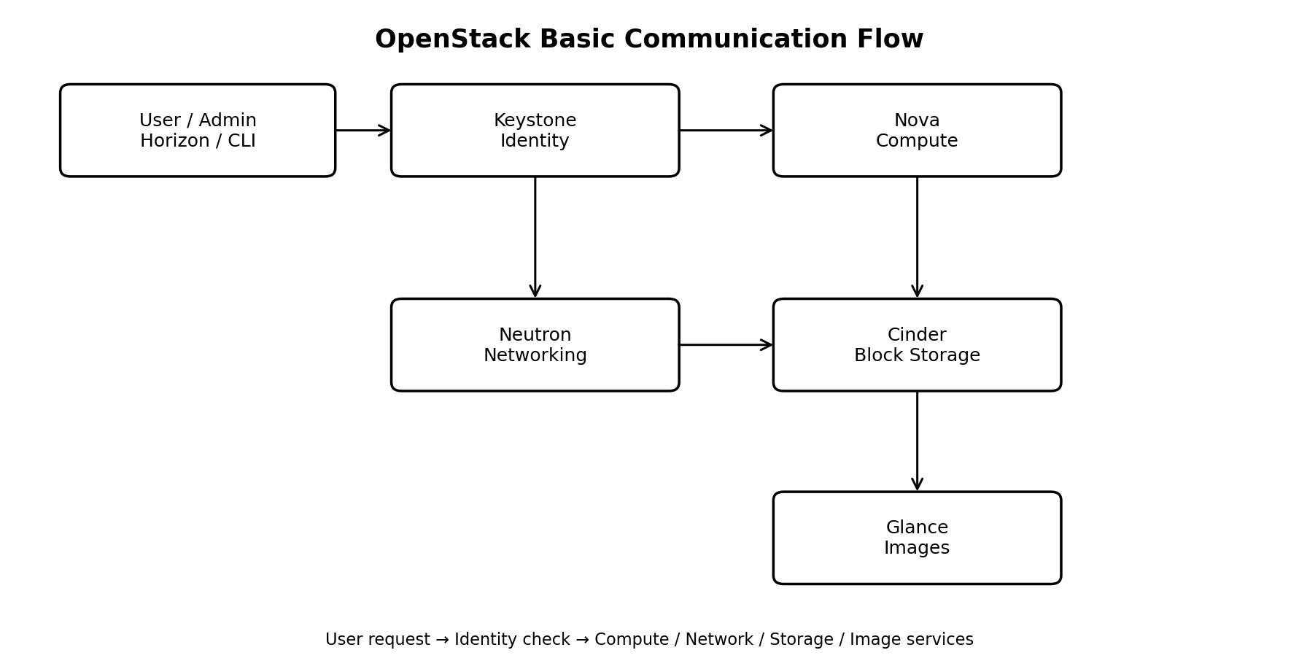
How the Communication Works
1. The user sends a request using Horizon, OpenStack CLI, or an application.
2. Keystone checks the user's identity and provides an authentication token.
3. The request is sent to the required service, such as Nova for an instance or Neutron for networking.
4. Nova can request an image from Glance and attach a Cinder volume to the instance.
5. Neutron provides the network, ports, and routing needed by the instance.
6. The services communicate through APIs and complete the requested operation.
Result
OpenStack uses separate services for identity, compute, networking, images, and storage. These services communicate through APIs to create and manage cloud resources.
Q2. Question: In OpenStack Create two instances with two separate volumes and network
Steps in Horizon
1. Log in to Horizon with the required project account.
2. Go to Project → Compute → Instances and click Launch Instance.
3. Enter a name such as Instance-1.
4. Select an available image, choose the required flavor, and select the required network.
5. Create or attach Volume-1 as the boot volume, depending on the available Horizon options.
6. Launch Instance-1.
7. Repeat the same process for Instance-2, but create/use Volume-2 as its separate volume.
8. Check that both instances are ACTIVE and each instance has its own volume.
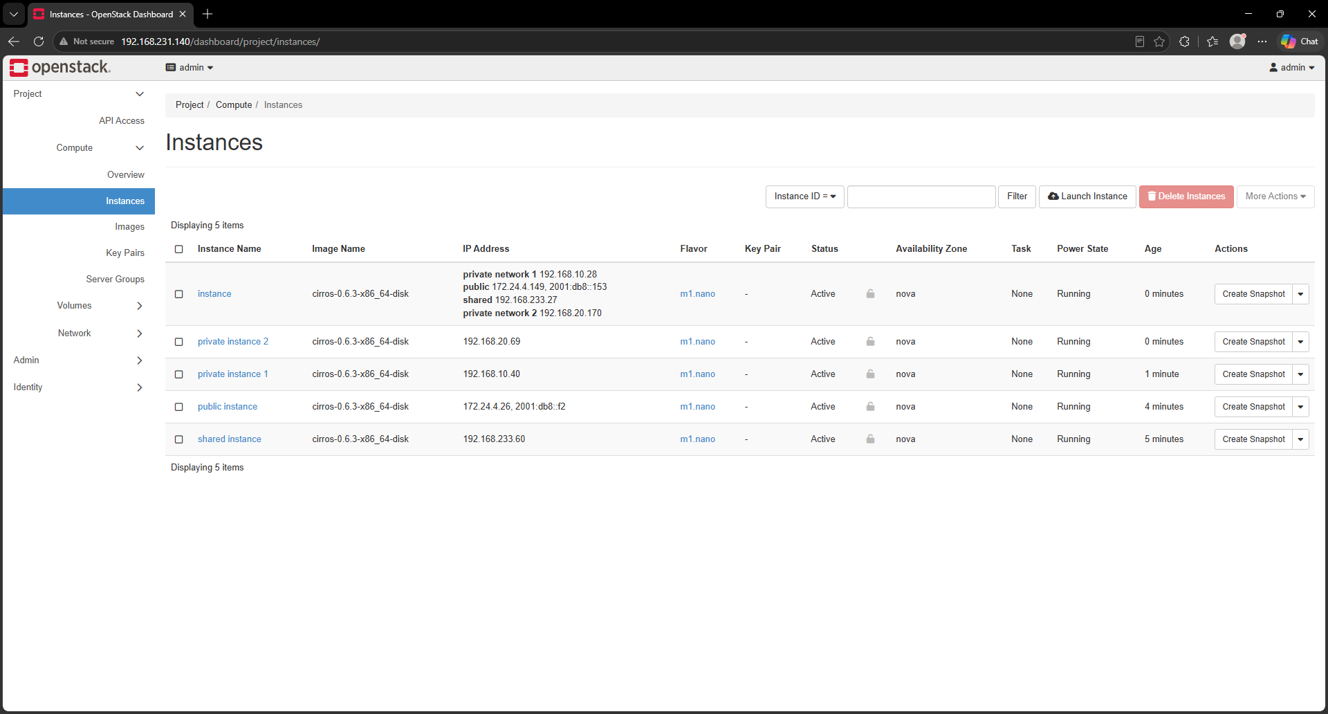Result
Two OpenStack instances are created successfully with separate volumes and network connectivity.
Q3. Question: Create internal and external network and assign it to routers and then instances
Steps
1. Open Horizon and go to Project → Network → Networks.
2. Create an internal network, for example Private-Network.
3. Create a subnet inside the internal network, for example 192.168.10.0/24.
4. Create or select an external network, for example Public-Network. The external network must be configured by the cloud administrator/provider.
5. Go to Project → Network → Routers and create a router, for example Router-1.
6. Open Router-1 and set the external gateway to Public-Network.
7. Add an interface to Router-1 using the Private-Network subnet.
8. Go to Project → Compute → Instances and launch or edit the instances.
9. Assign the Private-Network to the instances. The instances can then use Router-1 for external connectivity.
10. If external access to an instance is required, associate a floating IP from the external network with the instance port.
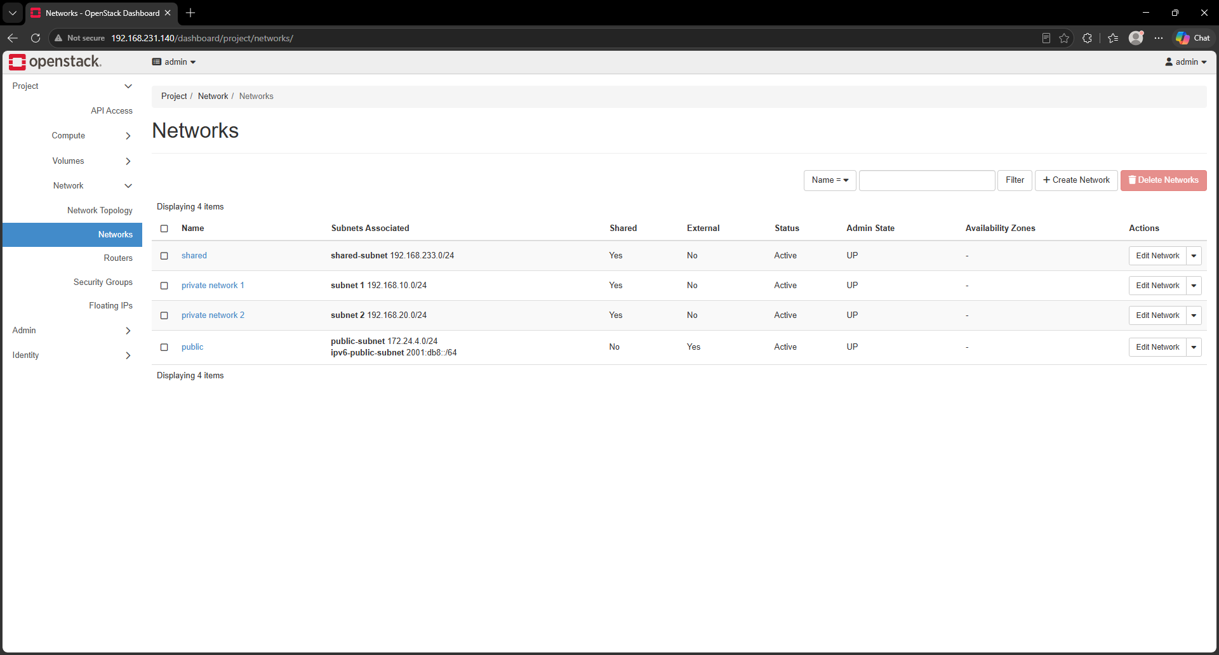Result
The internal network connects the instances, while the router connects the internal network to the external network. The instances can use the router for external connectivity when the required security rules and floating IP are configured.
DevStack Installation, Configuration & Web Access Guide
Section 1: DevStack Installation & Web Access
Step 1: System Package Update & Tool Installation
sudo apt update && sudo apt upgrade -y
sudo apt install -y git openssh-server
sudo systemctl enable --now ssh
sudo systemctl status ssh
Step 2: Create the Dedicated 'stack' User
DevStack should be run by a dedicated non-root user named stack.
sudo useradd -s /bin/bash -d /opt/stack -m stack
sudo chmod +x /opt/stack
echo "stack ALL=(ALL) NOPASSWD: ALL" | sudo tee /etc/sudoers.d/stack
sudo -u stack -i
Step 3: Clone DevStack and Configure local.conf
git clone https://opendev.org/openstack/devstack /opt/stack/devstack
cd /opt/stack/devstack
nano local.conf
Use a simple local.conf configuration such as:
[[local|localrc]]
ADMIN_PASSWORD=secret
DATABASE_PASSWORD=$ADMIN_PASSWORD
RABBIT_PASSWORD=$ADMIN_PASSWORD
SERVICE_PASSWORD=$ADMIN_PASSWORD
HOST_IP=$(hostname -I | awk '{print $1}')
Step 4: Execute DevStack Installation
./stack.sh
The installation time depends on hardware, network speed, and the services being installed. Wait for the script to finish successfully before using Horizon.
Step 5: Access OpenStack Horizon
hostname -I
# Open in a browser:
http://<YOUR_SERVER_IP>/dashboard
Username: admin
Password: secret
If the dashboard is configured on a different port or address, use the URL shown by the DevStack installation.

